Deque

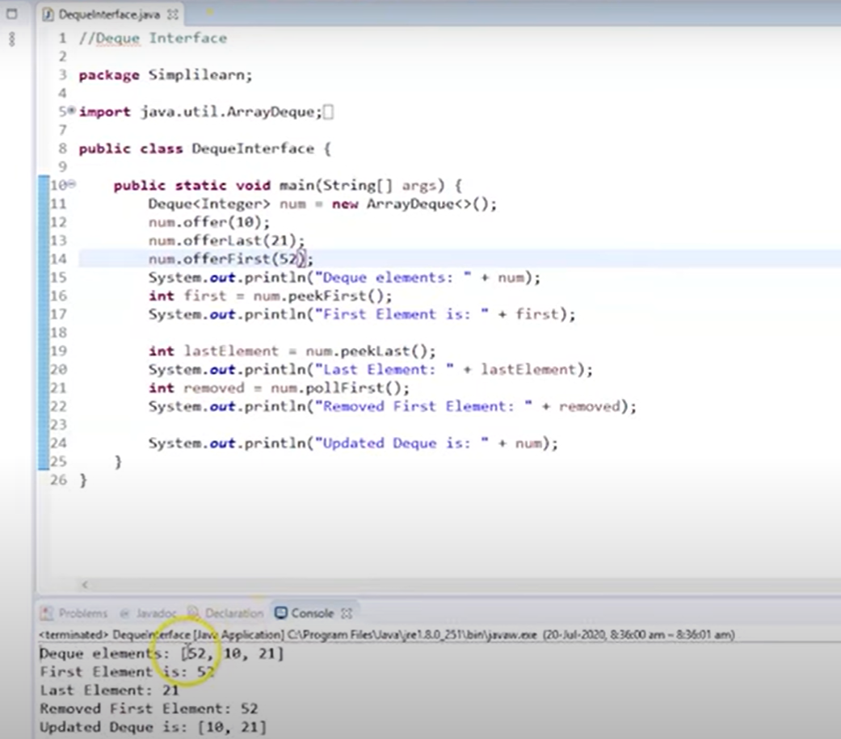

Map

SortedSet Interface

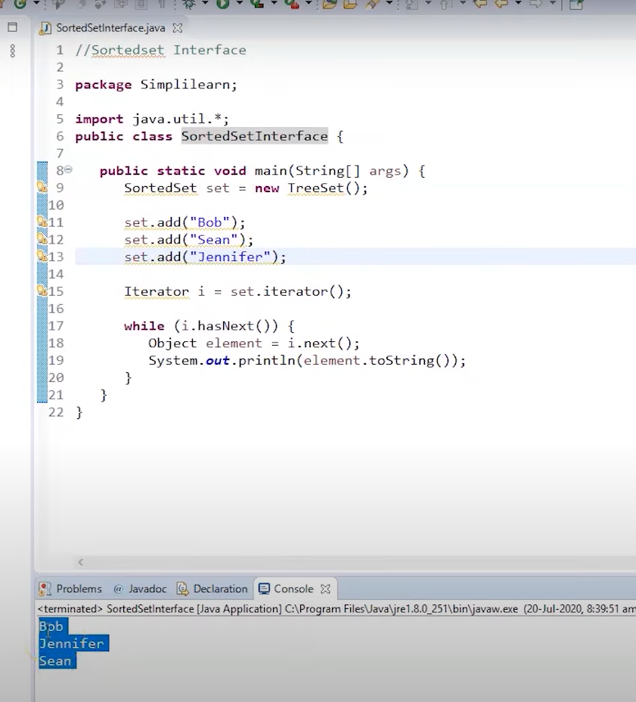

SortedMap

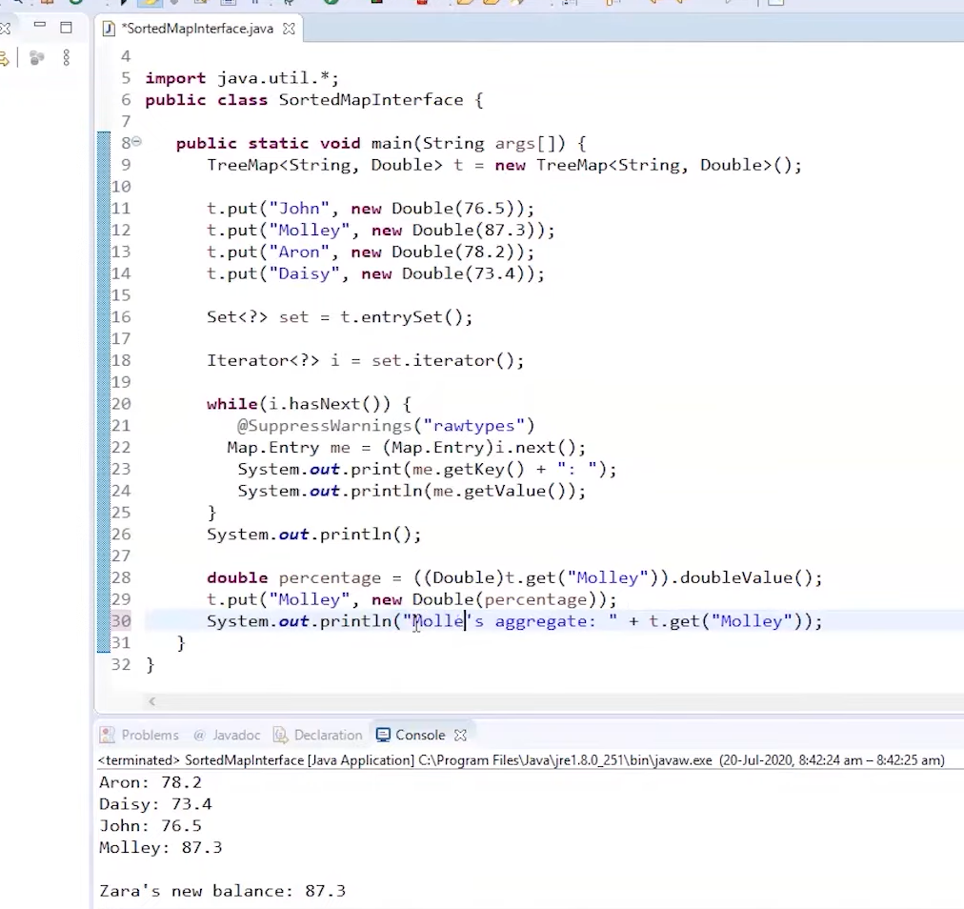

Hashset

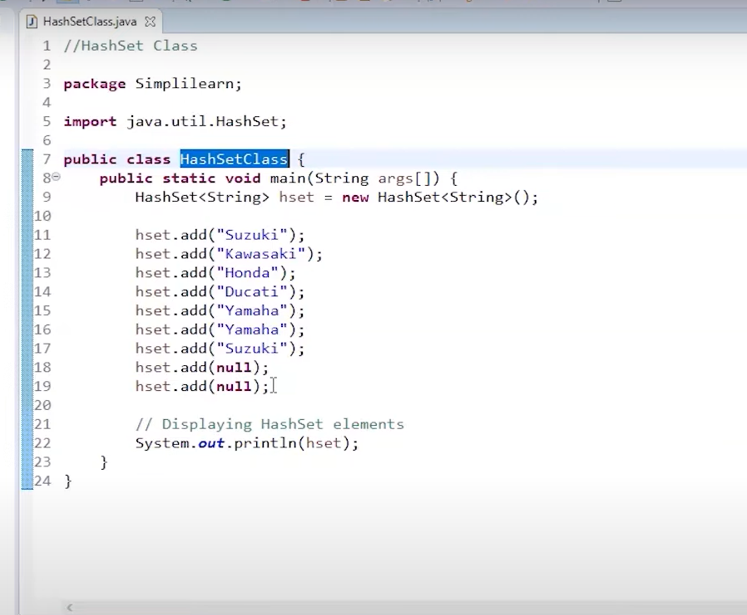

Output

TreeSet

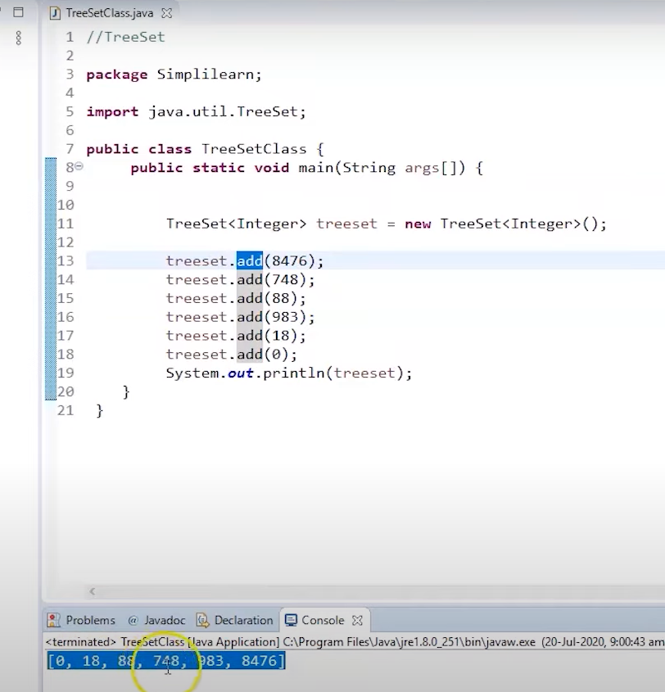

ArrayList

Doubly linkedList

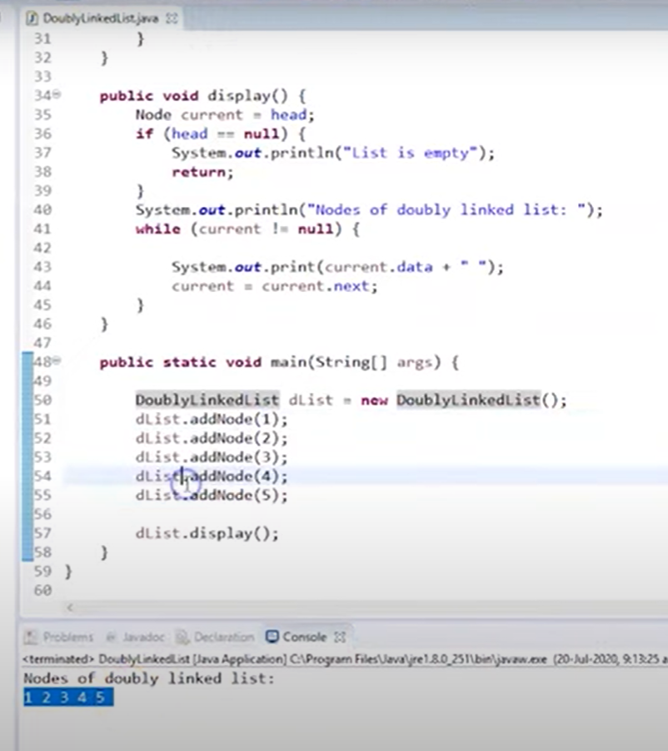

Circular LinkedList

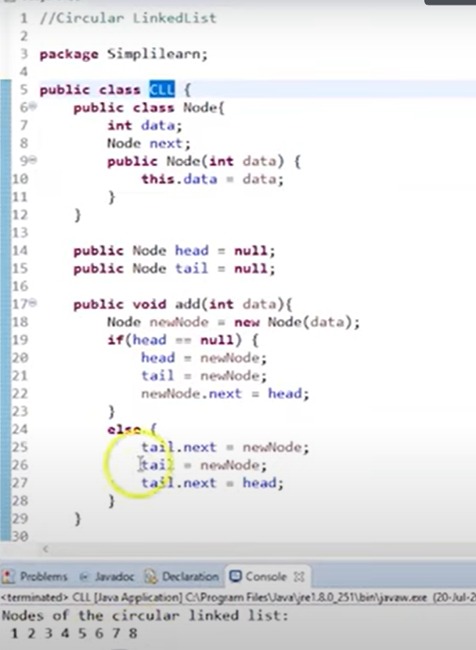

Hashmap

TreeMap Class

